Halswell Cricket Club

Established

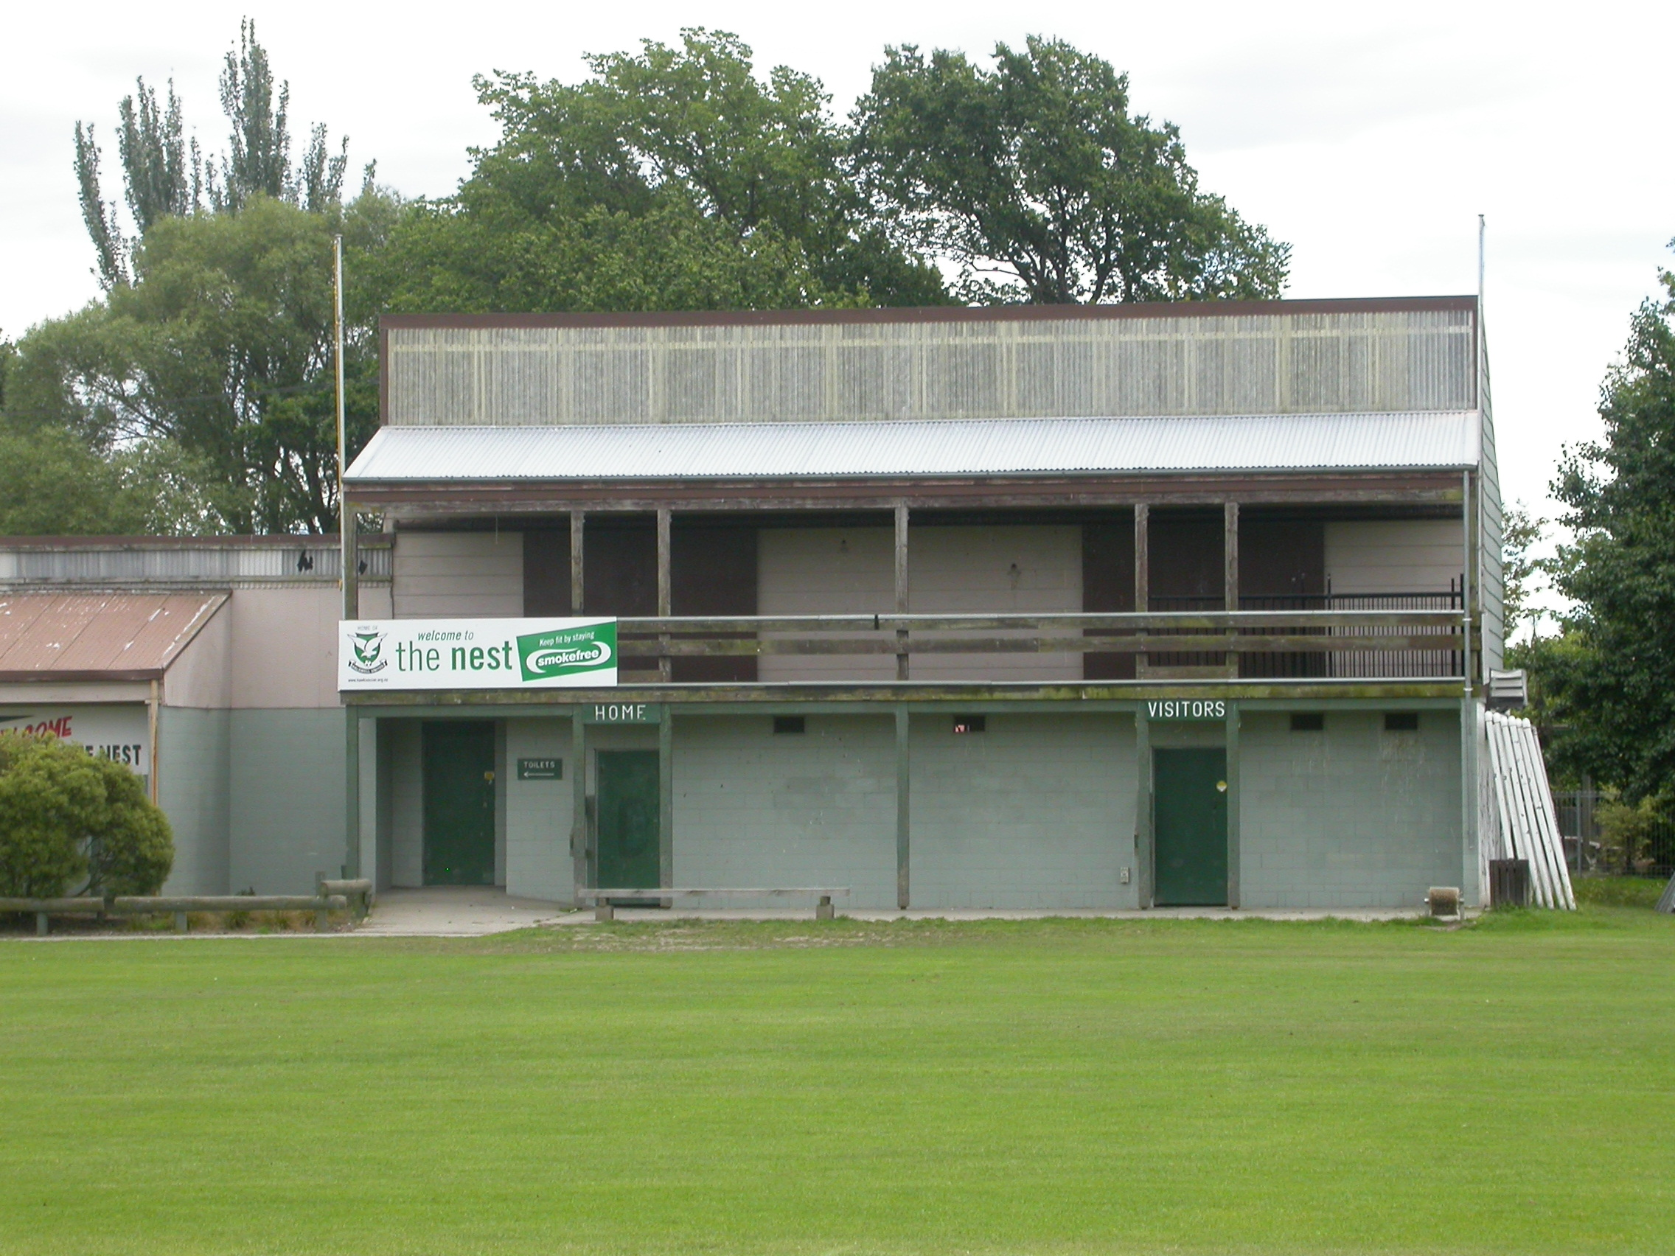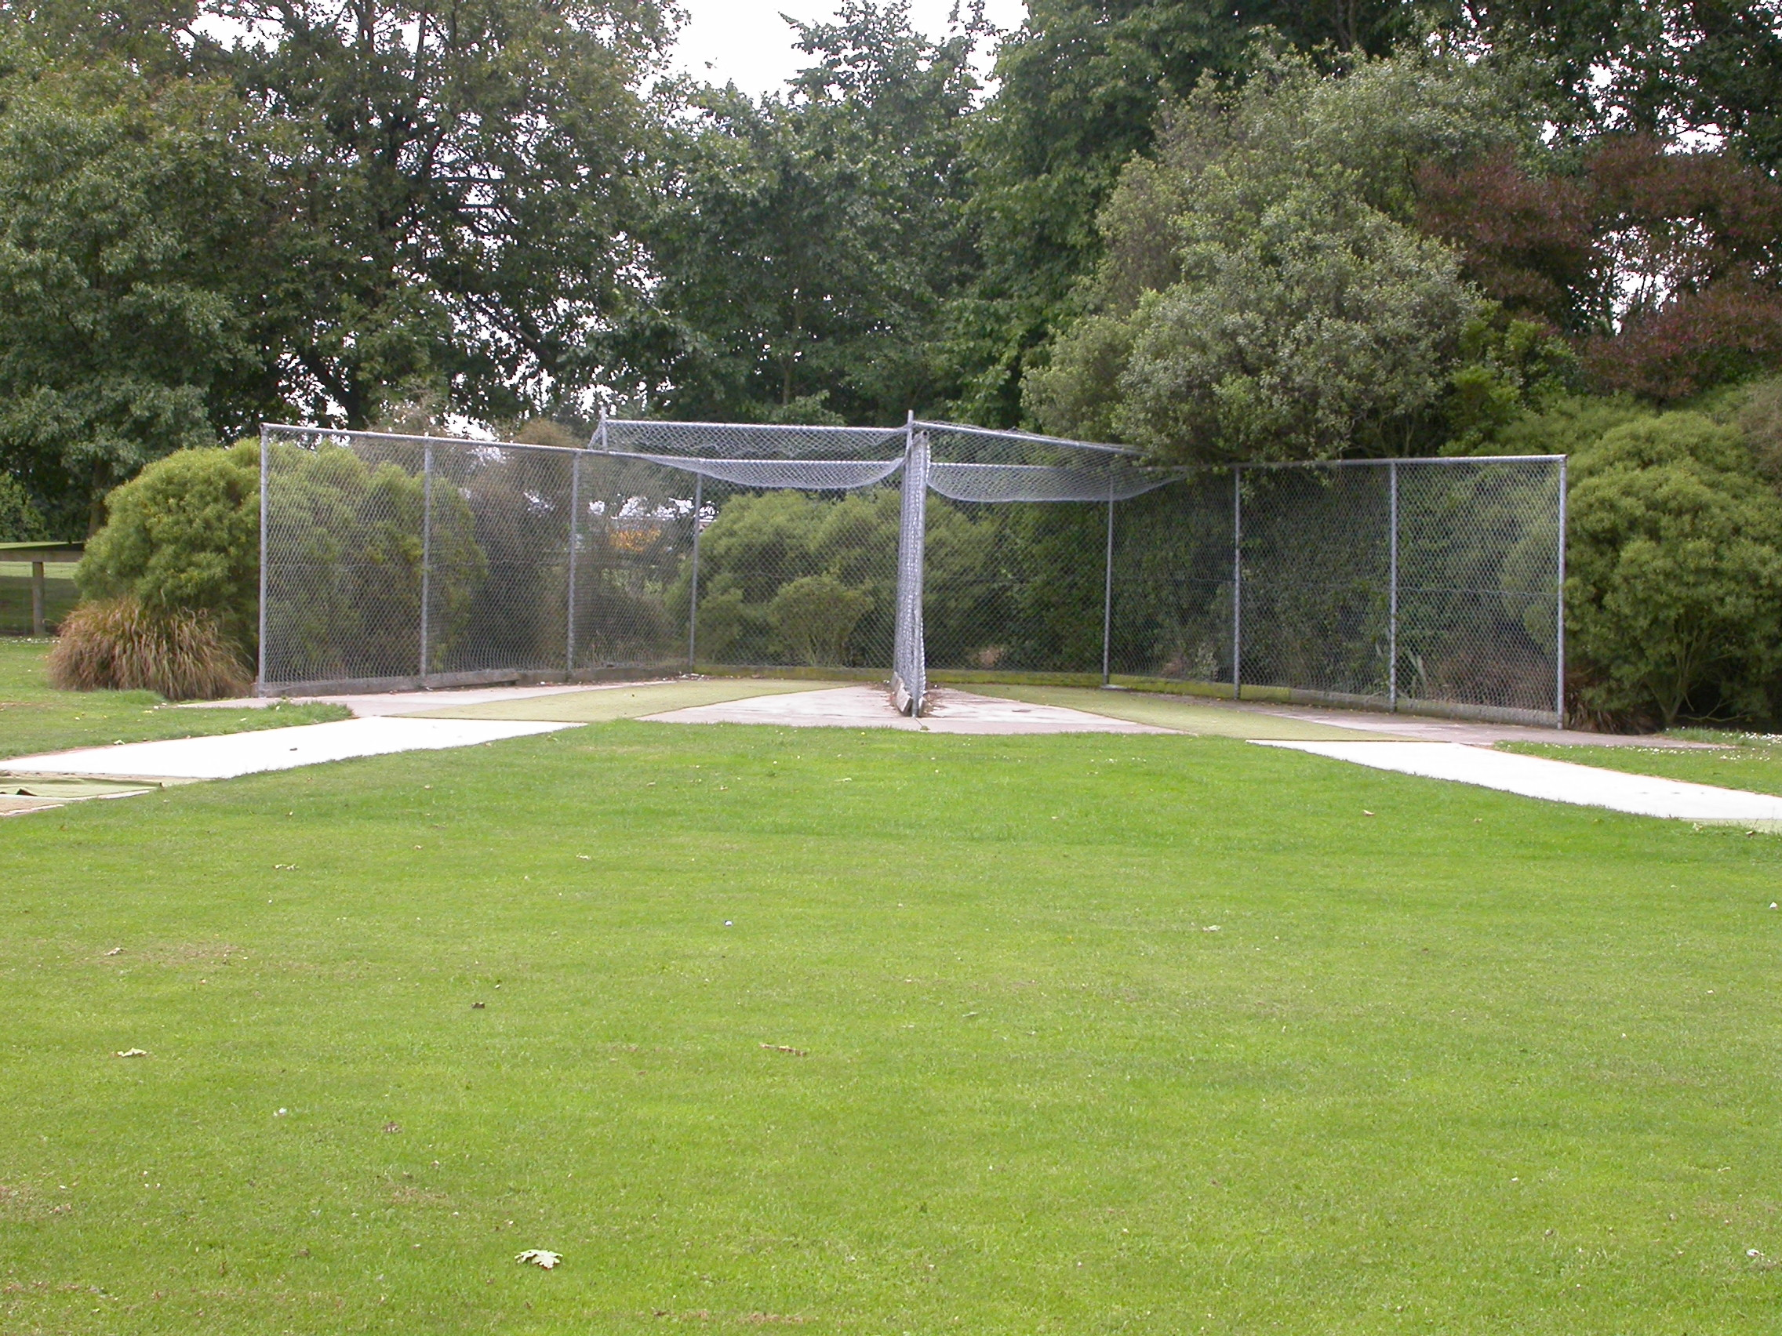

Home Ground Halswell Domain
Match pitches 3 grass match pitches
Practice pitches 2 artificial pitches
Entries 2001-02 3 men teams 14 junior teams
2002-03 3 men teams 13 junior teams
2003-04 2 men teams 14 junior teams
2004-05 2 men teams 13 junior teams
2005/06 3 men teams 16 junior teams
Grade wins last 5 years Nil

